DATA FLOW DIAGRAMS

When examining an existing Information System or analysing the Information that is going to be designed, it is important to recognise what the data is, where the data comes from, how it passes from one point to another within the Information System and finally how it will be used by the intended audience or user.
A Data Flow Diagram is one of the best ways to illustrate this.
Certain conventions are used that we will follow. ref 'Information Technology and you' pp191,192
Symbols used:
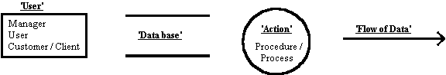
To create a data flow diagram, it is best to collect together the required information before you start.

Examples
(A) Finding / Using a book for research in a Resource Centre.
Lets say you decide to produce a data flow diagram to illustrate the procedure described above
.
Firstly decide on the probable users that may be involved in the procedure;
in this case it is very easy as it just the student borrower.
Secondly determine which Data bases the user(s) may need to interact with; again fairly simple in this case, the DYNIX system and the Books in the shelves.
Next decide on the probable 'Actions' that will need to be carried out to complete the procedure. It not necessary to be over enthusiastic but do allow for possible additions as your diagram progresses.
Searching the catalog for the required book,
Retrieving the book from the shelves,
Using the book to conduct the required research
Returning the book to the shelves or trolley
Last step is to work out the data that is going to be needed to carry out each of these actions
and then just put them together like a jigsaw puzzle,
Book title / Author / Subject matter to be able to search the catalog;
Retrieved Call # to be able to find the book in the shelves;
The book itself to be able to conduct the research and finally put it back.
and there you have it, just put it together and you have.........
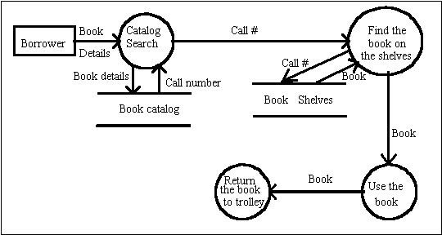

(B) Cash withdrawal from a bank.
